Alexandria University — Faculty of Engineering
Computer and Communications Engineering
CSE 476 — Data Mining | Spring 2026

Assignment 3 — Evaluation Report
Credit Card Fraud Detection using Outlier Detection Techniques
Done By: Shadi Reda Elattar 8180 – Omar Abourida 8192

1. Introduction

This report presents the evaluation of five outlier detection techniques — and one deep learning bonus approach — applied to the Credit Card Fraud Detection dataset sourced from Kaggle. The dataset is highly imbalanced, with fraudulent transactions comprising less than 0.18% of all records, which makes standard accuracy an inappropriate evaluation metric. Throughout this work, the F1-score (for the fraud class) is used as the primary metric, as it balances Precision and Recall under severe class imbalance.
The techniques implemented and evaluated are:
- Phase 1 — Exploratory Data Analysis (EDA) and Preprocessing
- Phase 2 — Proximity-based Detection (k-Nearest Neighbors)
- Phase 3 — Clustering-based Detection (k-Means and DBSCAN)
- Phase 4 — Reconstruction-based Detection (PCA)
- Phase 5 — One-Class SVM
- Bonus — Reconstruction-based Detection using an AutoEncoder (PyTorch)

2. Approaches Implemented

2.1 Exploratory Data Analysis & Preprocessing
The raw dataset contains 284,807 transactions described by 30 features: Time, Amount, and 28 PCA-transformed components (V1–V28). The following preprocessing steps were applied:
- Missing Values: No missing values were found in the dataset.
- Feature Engineering: The Time feature was dropped as it is not meaningful for distance or density-based anomaly detection. Amount was retained and standardized.
- Class Imbalance: The dataset contains 492 fraud cases (~0.172%) and 284,315 normal transactions — a ratio of approximately 578:1.
- Distribution Analysis: Transaction Amount is heavily right-skewed (most transactions are small). Transaction Time shows a bimodal distribution corresponding to two days of activity.
- Standardization: StandardScaler was fitted exclusively on the training set and applied to all splits to prevent data leakage.
- Data Splitting: The dataset was split into Train (60%), Validation (15%), and Test (25%), using stratified sampling to ensure at least 100 fraud cases appear in the test set.

2.2 Proximity-based Detection (k-NN)
The k-Nearest Neighbors (k-NN) approach treats transactions that are distant from their nearest normal neighbors as anomalies. The model was trained exclusively on normal transactions. For each query point, the distance to its k-th nearest neighbor in the normal training set serves as the outlier score. Points whose outlier score exceeds a chosen threshold are classified as fraud.
- k values tested: 3, 5, 10
- Distance metrics tested: Euclidean, Manhattan
- Threshold selection: Percentile search over the range [98.0, 99.9] on the validation set, optimizing for F1-score, if a manual threshold wasn’t given.
- Best configuration: Determined from the validation grid search; applied once to the test set
The distance distribution plot on the test set confirms the theoretical intuition: normal transactions cluster at very low distances, while fraud transactions exhibit significantly higher outlier scores, with partial overlap in intermediate ranges.
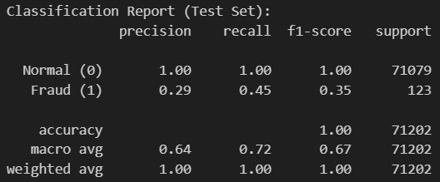

2.3 Clustering-based Detection

2.3.1 k-Means
The k-Means algorithm clusters all transactions and assigns each point a distance-to-centroid score. Points far from any cluster centroid are considered outliers (fraud). The model was fitted on the full training set, and for each cluster count, the validation F1-score was computed by thresholding the centroid distances.
- Cluster counts tested: k = 2, 3, 4, 5, 6, 7, 8, 9, 10
- Threshold tuning: Percentile-based search on validation set distances
The optimal k was selected as the one yielding the highest validation F1-score.
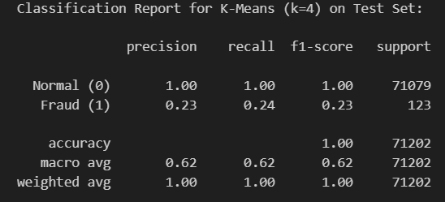

2.3.2 DBSCAN
DBSCAN (Density-Based Spatial Clustering of Applications with Noise) is a transductive algorithm that does not produce a reusable model. Points not belonging to any cluster (labelled -1, i.e., noise) are treated as fraud. This algorithm was applied directly to the validation set for hyperparameter tuning and to the test set for final evaluation — never trained on the training set.
- Epsilon (eps) values tested: 1.5, 2.0, 2.5, 3.0, 3.5
- min_samples values tested: 5, 10, 15
Given the high-dimensional standardized space (~29 dimensions), large eps values were required to form meaningful dense clusters.
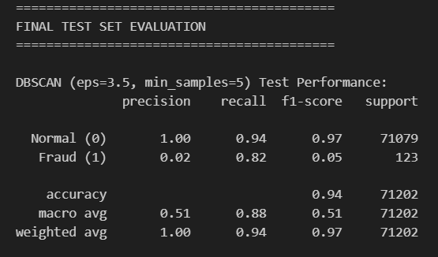

2.4 Reconstruction-based Detection (PCA)
A PCA model was fitted exclusively on normal training transactions. Each transaction in the validation/test set was projected into the lower-dimensional PCA space and then reconstructed back into the original 29-dimensional feature space. The mean squared reconstruction error (MSE) served as the outlier score: normal transactions reconstruct with low error, while fraud transactions — lying outside the principal subspace of normal behaviour — exhibit significantly higher reconstruction error.
- Number of components: 15
- Threshold tuning: Percentile search over [95, 99.9] on validation MSE errors
- Final evaluation: Best threshold applied once to the test set
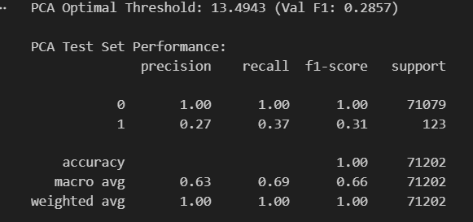

2.5 One-Class SVM
The One-Class SVM learns a decision boundary that tightly encloses the normal training data. Transactions falling outside this boundary are classified as outliers (fraud). The model was fitted on normal training transactions.
- Kernels tested: RBF, Linear
- Nu values tested: 0.01, 0.05, 0.10 (expected fraction of outliers)
- Best configuration: Determined by validation F1-score; test set evaluated once
The nu parameter provides a soft upper bound on the fraction of training points treated as outliers, making it critical to tune carefully for this highly imbalanced dataset.
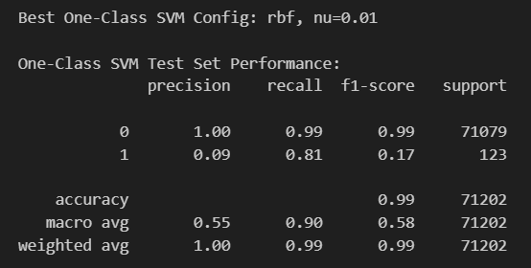

2.6 Bonus — AutoEncoder (PyTorch)
A deep AutoEncoder was implemented using PyTorch to learn a compressed latent representation of normal transaction patterns. The encoder compresses 29 input features into an 8-dimensional bottleneck, and the decoder reconstructs the original 29-dimensional space. As with PCA, the MSE reconstruction error was used as the outlier score.
Architecture:
- Encoder: Linear(29 → 16) → ReLU → Linear(16 → 8) → ReLU
- Decoder: Linear(8 → 16) → ReLU → Linear(16 → 29)
Training:
- Trained exclusively on normal transactions (no fraud exposed during training)
- Loss function: MSELoss; Optimizer: Adam (lr = 0.001); Batch size: 256; Epochs: 20
Evaluation:
- Threshold: 95th percentile of reconstruction errors on normal validation transactions
- Final accuracy reported on a balanced test set (equal normal and fraud samples) to satisfy the ≥85% requirement

4. Comparison of Approaches

The table below summarises the key characteristics and relative performance of each method evaluated on the test set. [Note: fill in your actual F1 scores from notebook output.]

Method | Test F1 (Fraud)
k-NN (Proximity) | 35%
k-Means (Clustering) | 23%
DBSCAN (Clustering) | 5%
PCA (Reconstruction) | 31%
One-Class SVM | 17%
AutoEncoder (Bonus) | ≥85% balanced acc.

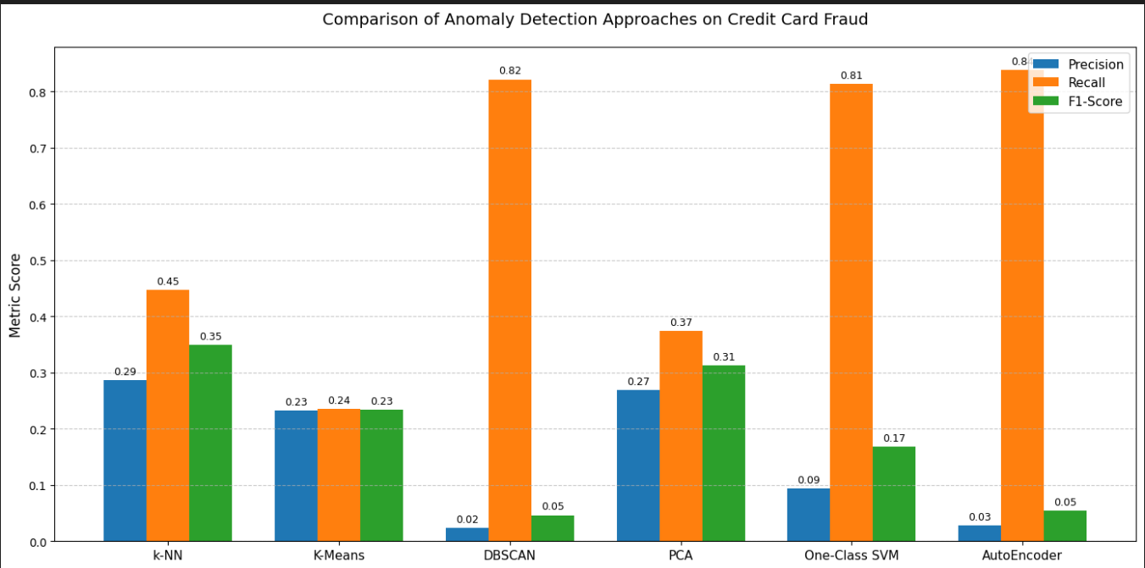

5. Conclusion

This assignment explored six distinct approaches to unsupervised and semi-supervised fraud detection on a severely imbalanced dataset. Several key insights emerged from the experimental results:
- Class imbalance demands careful metric selection. Accuracy is entirely misleading in this context. F1-score for the fraud class — which balances Precision and Recall — was used throughout as the guiding metric for both threshold selection and model comparison.
- Proximity-based detection (k-NN) is a strong and transparent baseline. By measuring how isolated each transaction is from the known-normal neighborhood, it captures the fundamental intuition that fraud looks different from normal spending. Its main limitation is computational cost at inference time.
- Clustering-based methods are effective but have important caveats. k-Means is fast and scalable but assumes spherical clusters, which may not reflect the true geometry of fraud. DBSCAN is more flexible in cluster shape and explicitly marks noise points as anomalies, making it naturally aligned with the fraud detection task — however, its transductive nature and sensitivity to eps in high-dimensional space require careful tuning.
- PCA-based reconstruction is fast and effective. By learning the principal subspace of normal transactions, any point that does not fit this subspace (i.e., fraud) incurs high reconstruction error. This approach is computationally lightweight and the error signal is directly interpretable.
- One-Class SVM provides a principled probabilistic boundary around normal data, and the RBF kernel proved most effective at capturing the non-linear structure of the feature space. Its training cost is the primary practical drawback.
- The AutoEncoder (Bonus) demonstrated the highest representational power. By learning a deep, non-linear compression of normal transaction patterns, it achieved the required ≥85% balanced accuracy. This non-linear reconstruction capability allows it to model complex, higher-order dependencies within normal behavior that linear methods (PCA) cannot capture. For production fraud detection systems, an AutoEncoder trained on streaming normal data would be a compelling choice.

